The Urban Homesteader
  - April 2014
eatING (Mostly) local and seasonal
1 bunch kale (over-wintered)
1 clove garlic
¼ cup dried apple or raisins
1 tsp allspice
¼ cup pine nuts (Navajo)
Sautee thinly sliced kale for 5 - 8 minutes on medium heat. Add garlic and dried fruit. Cook an additional 5 minutes. The last two minutes, add ¼ cup water with allspice mixed in and put a lid on the pan to steam the fruit and kale. Remove lid and stir. Add a dash of salt. Sprinkle pine nuts on top.

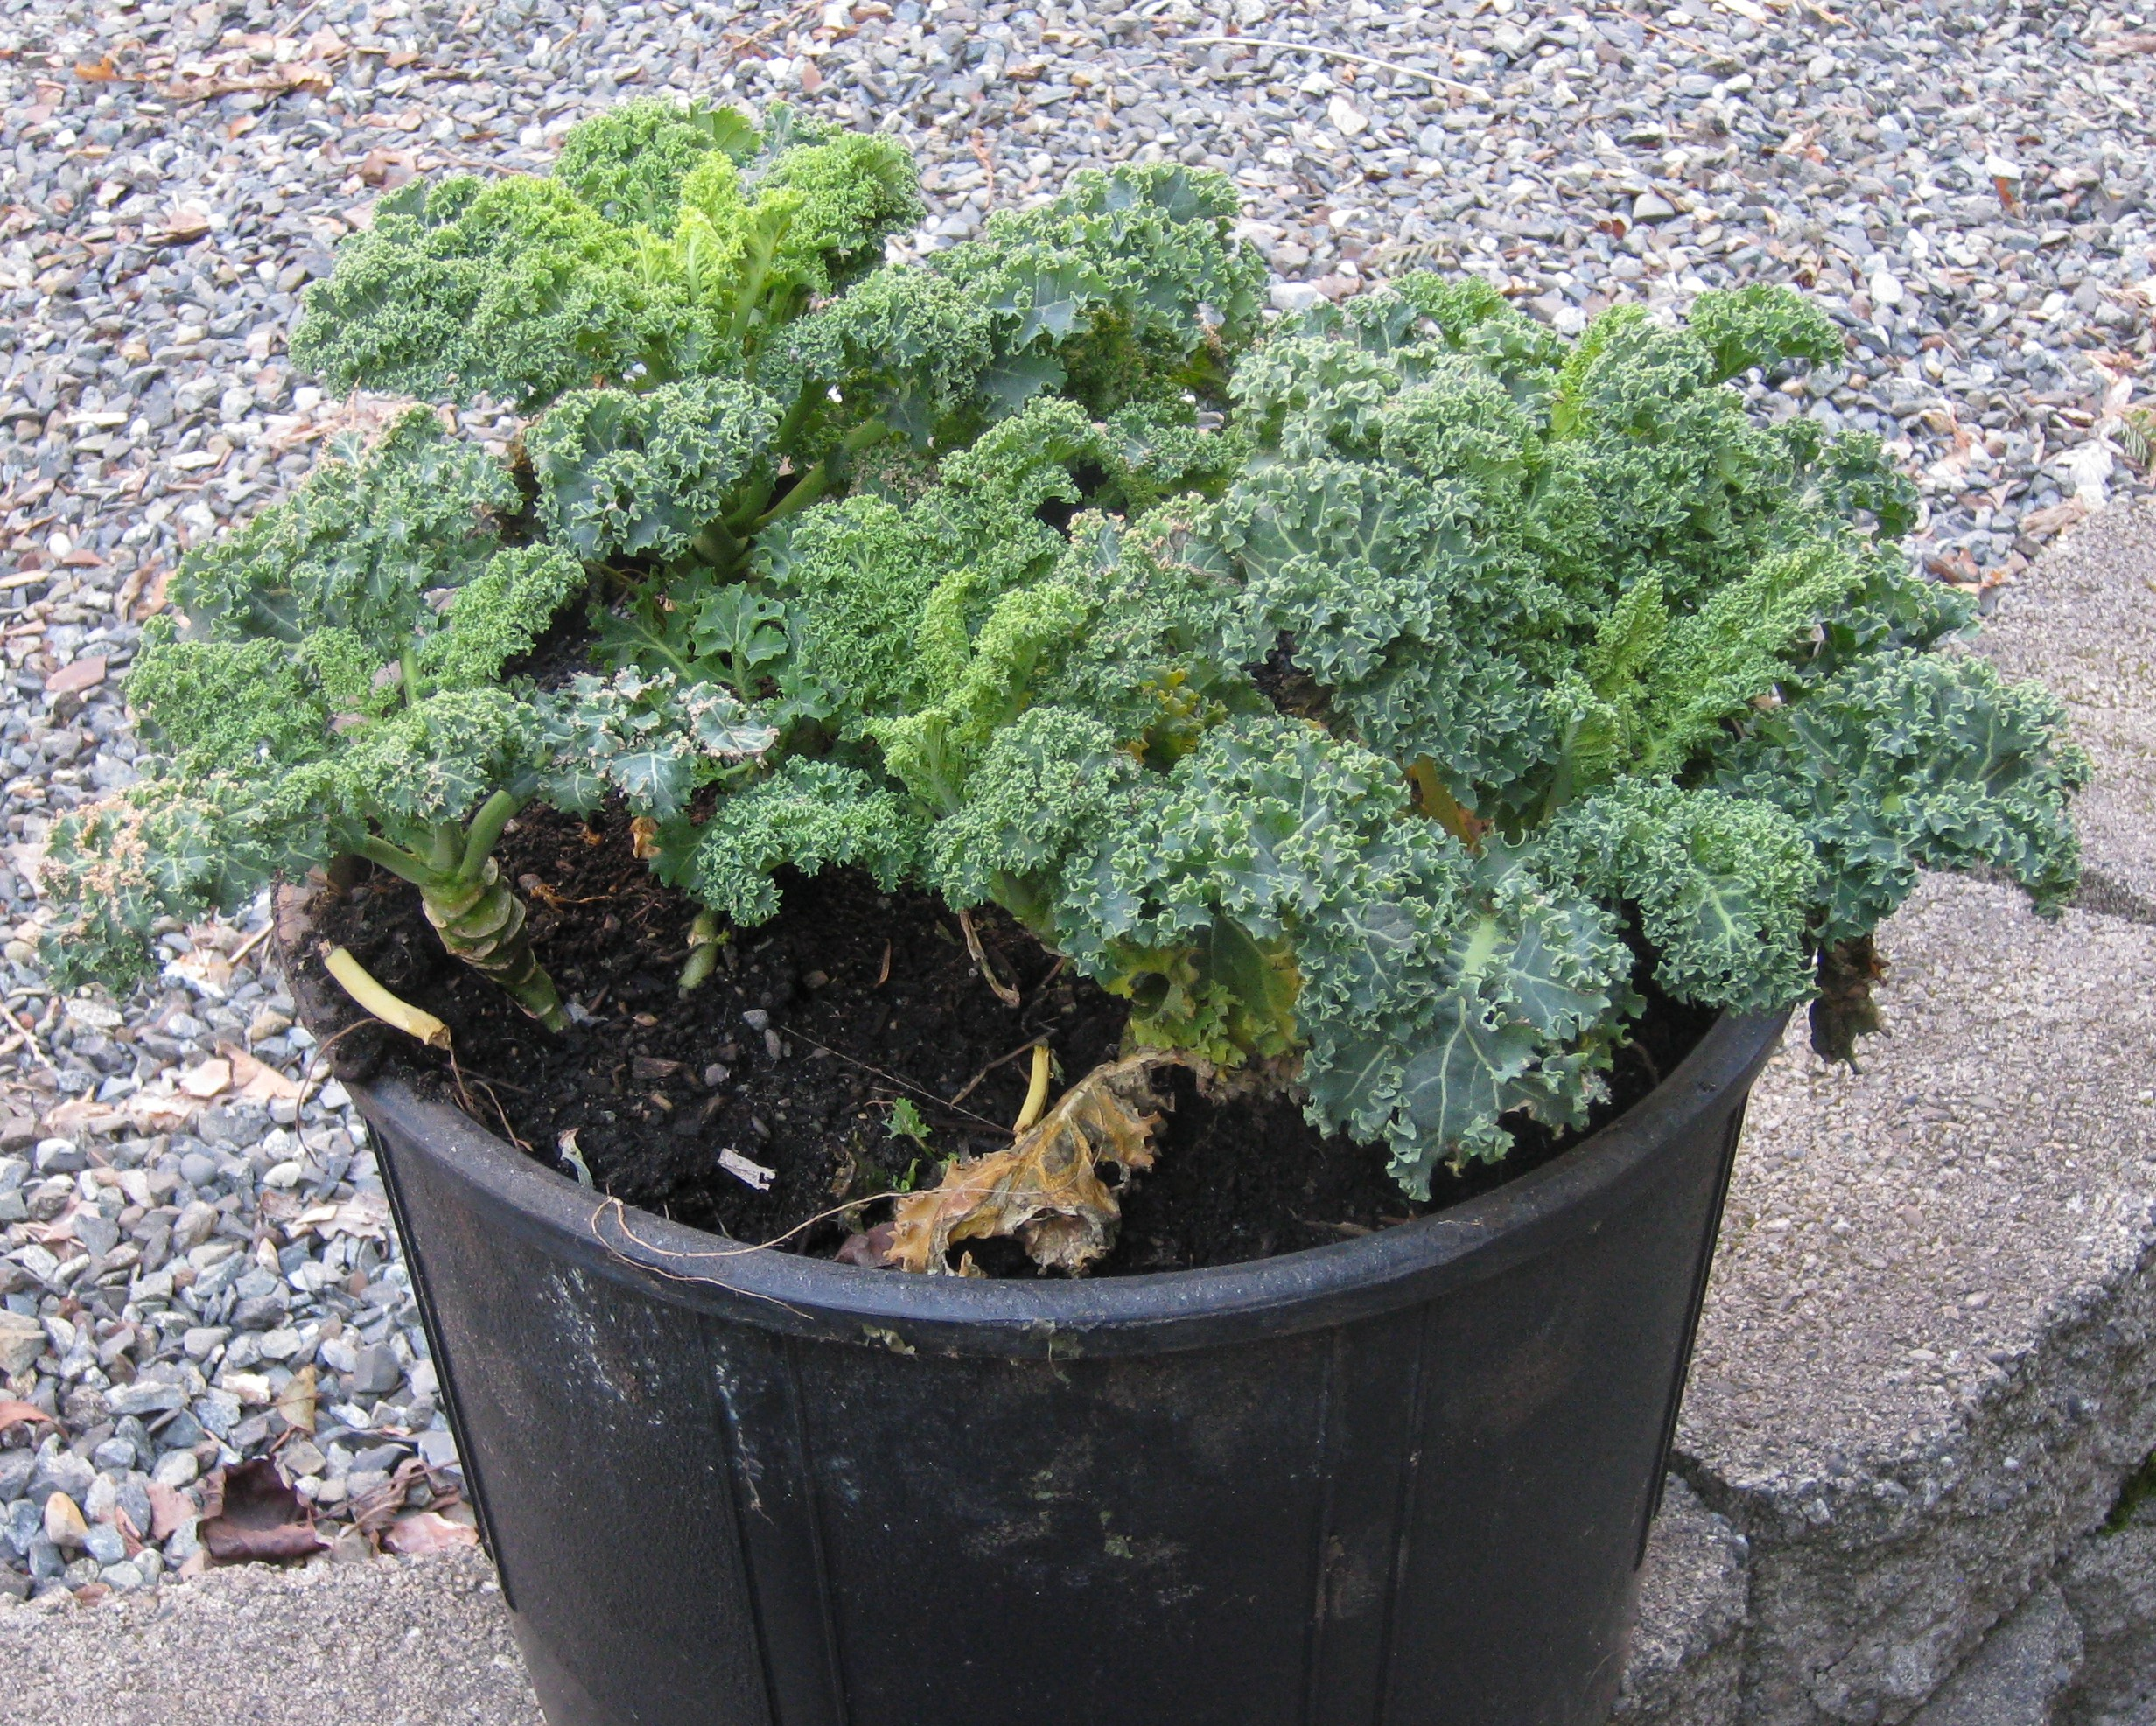
Over-wintered kale – before dinner.

The Urban Homesteader Reflects on Freezers and Countertop Bacteria

This evening, I made Vietnamese beef rolls. The only ingredients not local were curry powder and fish sauce. The garlic, chopped onions, and lemon grass all came from my root cellar or the freezer (lemon grass can be grown as an annual here in the PNW – though much smaller than the imported variety sold in stores, homegrown is much more pungent and it freezes well). The $4.75 per pound hamburger came from a Yakima Grass-fed Angus free-range, antibiotic-free animal. A New York steak also costs $4.75 per pound, when one orders ¼ of an animal directly from the farm.
Cutting out the store gives the rancher more money and my family a really good deal on beef products. Win-win. (Though perhaps the tasty grass-fed Angus does not view it this way.)
That’s why a freezer is an indispensable tool for an urban homesteader. It allows me to purchase from small, local producers who have more land than I do on my quarter acre lot. Sometimes my husband trades construction work for food, and the food is even “cheaper.”
Since I buy in bulk to feed a family of four, I need two Energy Star chest freezers that cost very little in electricity to run. They received and stored that home-delivered ¼ beef, and they are still partially filled with last summer’s bounty – harvested, U-picked, or bought cheaply in season and frozen. We’ve got homegrown jalapenos and Hungarian hot wax peppers, two bags of homegrown basil (frozen basil tastes worlds better than dried – add olive oil to avoid the basil blackening), peaches, raspberries, strawberries, and blueberries.
We’re mixing the berries with our yogurt, which I make using fil – a culture from Sweden that turns milk and half-and-half into Fil Mjolk, clotted cream, and soft cheese. The beauty of fil is that it does it’s bacterial thing at room temperature. No heating tray. No boiling and cooling. Just mix pasteurized milk with fil starter, and twenty-four hours on the kitchen counter later you’ve got a kefir-like yogurt. For sour cream, add fil to half and half.

What Should an Urban Homesteader Grow?
Small gardens can produce an amazing amount of useful food for a family, as long as the right type of plants are selected. Here are a handful of rules I have learned from more experienced gardeners (and by trial and much error):
Rule 1: Plant what your family will eat. If kale isn’t something you commonly eat, then don’t bother growing it.
Rule 2: Take the time to learn how to succession plant, so your limited garden space is continually in production. Radishes, lettuce, spinach, and Asian greens mature early enough to be followed by May summer crops (tomatoes, squash, peppers, New Zealand spinach, chard, carrots, beets, beans). Start fall and winter brassica and greens in pots next to your garden (so you remember to water them) and move out into the garden once the summer crops are done. Add a thick layer of compost and a little organic fertilizer before planting out the fall starts. Extend the season with cloches and low tunnels.
Rule 3: Select plants that don’t take up a lot of space or can be coaxed into growing wildly. For example, one square foot of an intensive-method garden bed can produce 4 bush bean plants, 9 pole bean plants, 9 carrots, 9 onions, or 9 beets (plus beet greens). A 9 square foot box can produce 45 pounds of potatoes by adding a frame, some cheap cedar fencing boards (which can be re-used for years), and twelve inches of compost (compost super-charges the potatoes so they produce more than the average 4 pounds per plant; the compost goes back onto my beds in the fall).
Rule 4: Go vertical. A zuchetta rampicante (yes, that means rampant zucchini), can be grown in a 4 foot box with 15 pole beans if these vining plants are trellised. Besides, a 3 foot long squash hanging 6 feet in the air looks cool.
Want to see how all this works? Stop by the east side of the greenhouse (south of the R Building). We’ll be modeling an intensive and accessible garden there. You can also join me for next quarter’s gardening seminars, offered through the Faculty Commons.

Cutting Hair & Stretching Dollars
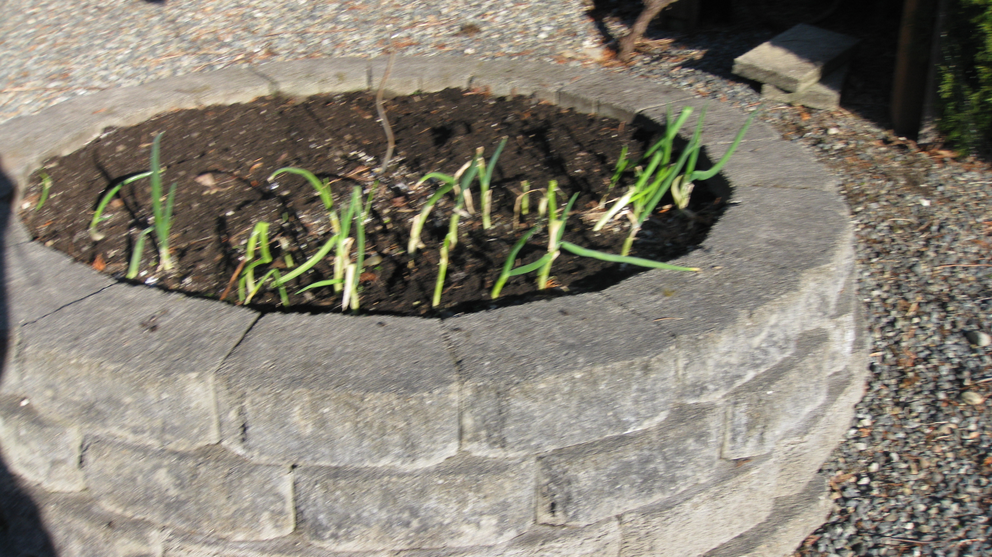

Over-wintered onions. This 4 foot diameter bed contained over 200 scallions – this is what is left after a winter of dining.

One might not think of hair cutting as a part of homesteading, but I save $60 every six weeks by cutting my three menfolk’s hair. After some trial and error -- luckily, hair grows back at ½ inch per month on average -- I’ve gotten skilled enough people compliment them. Even my eldest son prefers my hair cuts to a paid stylist. I only see a cheap hair stylist twice a year to deal with my long locks (I’d rather pound my hand with a rock than let one of my menfolk cut my hair). In between visits, I trim my bangs and the layered sides.
All told, I save over $500 per year. My four year old professional-grade hair trimmer cost $50. Not a bad investment.
I can take a week-long vacation with my family for $500 over spring break.

