Bellevue College Governance
Infrastructure Council

Bellevue College Governance’s Structure

Description:
Bellevue College Governance facilitates informed decision-making in the overall interest of the institution. All members of the college community have the opportunity to express opinions and make recommendations, and the system provides structures through which these opinions and recommendations will be considered for all important decisions. Key areas for governance input include strategic direction, resource acquisition and allocation, curricular and programmatic issues, and policy. Governance does not address matters of compensation, benefits, working conditions, personnel matters, grievances or other management issues.
BCG consist of a College Assembly and 8 Councils:
Four Constituency Councils: Student Council, Faculty Council, Classified Council and Exempt Council
Four Functional Councils: Academic programming (Faculty Council), Student Success Council, Resources Council & Planning, Diversity & Inclusion Council, and Infrastructure Council.
The College Assembly and the Councils develops and forward advisory opinions and recommendations to the President and other leadership as needed: Union, Management and Board of Trustees.

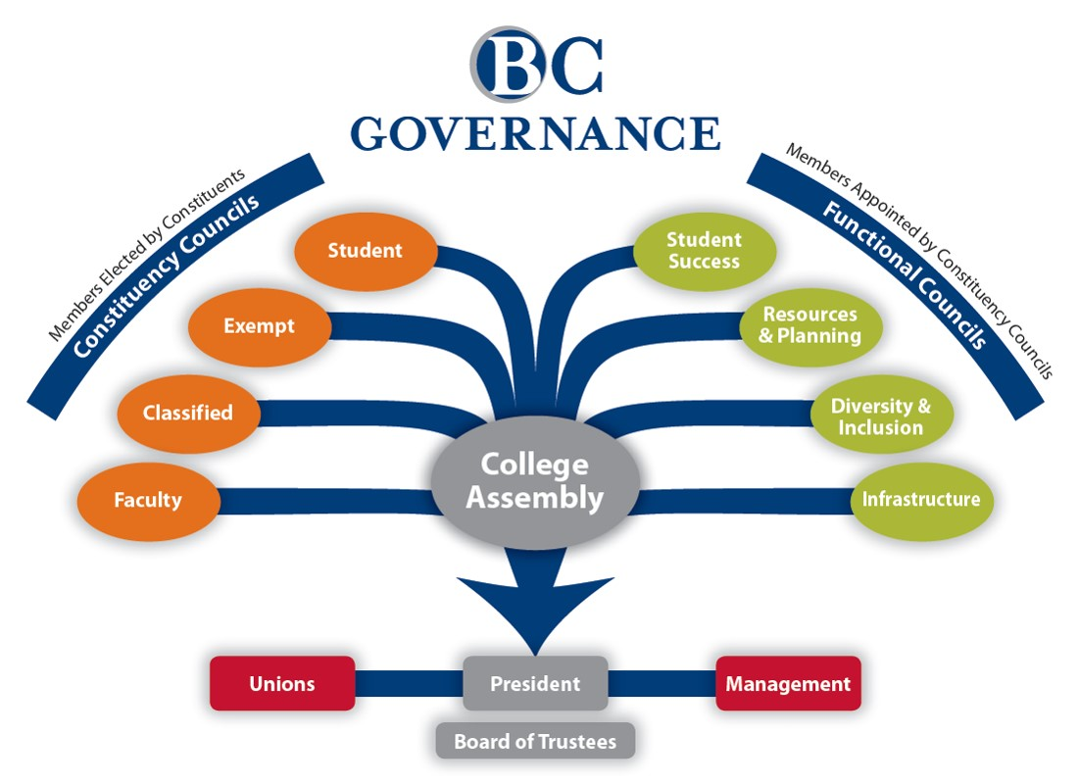
Infrastructure Council:
"The Infrastructure Council (IC) provides a forum to consider the effectiveness of nonacademic support functions, including technology, facilities, and auxiliary services. The IC will make recommendations to the president, College Assembly or other councils, as appropriate, for further consideration and action. Its membership consist of twelve members and two nonvoting resource liaisons."

Member Description:
Represent the student body every other Wednesday, 2:45pm on the Infrastructure Council for the 2017-2018 academic year (1 year term limit). Present an update on the Infrastructure Council to the Student Council (at an ASG Board of Directors Meeting) on a monthly basis.

Minimum Qualifications:
- Minimum 2.5 cumulative BC college-level GPA at the time of application or 2.5 cumulative quarterly BC college-level GPA for the two (2) previous consecutive quarters, and maintain a minimum 2.5 cumulative BC college-level GPA throughout employment term.
- Must be registered for a minimum of (5) BC credits during fall, winter, and spring quarter.
- Must have completed a minimum of (12) BC college level credits at the time of application.

REQUIRED DOCUMENTS TO SUBMIT:
To be considered for this position, applicants must meet the minimum qualifications and must submit a complete application packet which includes the following:
- Personal statement highlighting your contributions to the Bellevue College community. Provide as much detail as possible. (no longer than two one-sided pages maximum, double-spaced, 12-point font, and 1-inch margins.) Include in your personal statement:
  - Why you would like to serve on the Infrastructure Council
  - Why you would be a good student representative for the Infrastructure Council
- Unofficial transcript
- Letters of recommendation are not required but will be considered
- Resume (No longer than three pages). Please include your relevant experience and activities in:
  - Employment/internship
  - Community Service
  - Extracurricular Activities
  - Leadership Experience
  - Examples of Advocacy

APPLICATIONS MUST BE SUBMITTED TO:
Student Programs, C212
Front Desk
Bellevue College
3000 Landerholm Circle SE
Bellevue, WA 98007-6484

APPLICATIONS OPEN UNTIL FILLED:

Student Programs Summer Office hours:
7:30 AM to 5:00 PM Monday-Thursday and 8:00 AM to 12:00pm on Friday. Closed weekends and holidays. For information or to request an application send an e-mail to lameshia.reese-taylor@bellevuecollege.edu
Student Name ______________________________________________________
Student ID Number ___ ___ ___ -___ ___ -___ ___ ___ ___
Bellevue College Email _________________________________________________________
Phone (___ ___ ___) ___ ___ ___ -___ ___ ___ ___

