Steps to Upload an Exam or Add Test Instructions in MyDRC
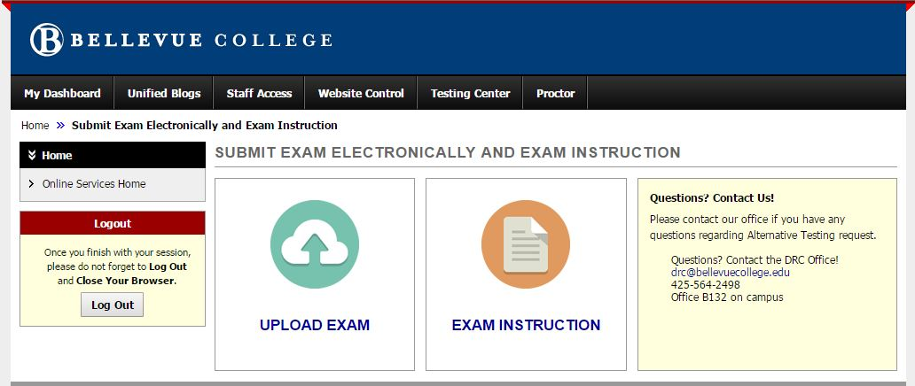
- Follow the link included in Testing Appointment Approval or Reminder email:
- Click on “Upload Exam” (for Exam Instruction ONLY, skip to #9)
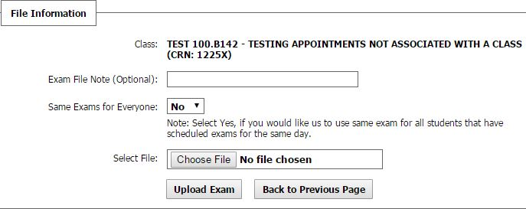
- Add an “Exam File Note” (e.g. NUTR 100 Quiz 4)
- Same exams for everyone?
(If yes, only one upload per class is necessary!)
- Click “Choose File” and select file to upload (3MB size limit)
- Click “Upload Exam”
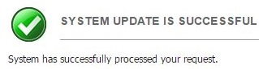
- SUCCESS!
- If you have additional files to upload, repeat steps 3-7 for each file up to 5 total files, otherwise click “Back to Previous Page” to Add Exam Instruction.
- Click on “Exam Instruction”
- Answer the three “Additional Exam Instructions” questions:
  - Does the time given to class to complete this test (included in the email reminder) need to be adjusted?
  - Are students allowed any additional testing materials (formula sheet, note card(s), etc.) not already listed on the MyDRC Test Proctoring Form?
  - Are there any other additional instructions, or changes to instructions given on the MyDRC Test Proctoring Form, that the student(s) should be aware of when taking this test?
- Click “Submit Exam Instruction” to add these instructions
- SUCCESS!

