

# FALL 2017 FACULTY COMMONS PROGRAM

Welcome to Fall 2017! We hope you had an adventurous summer.

As we begin Fall Quarter, we welcome our new faculty to Bellevue College (BC) while also welcoming Tonya Estes as our new Chair, and Tim Jones as the new Tenure Track Mentoring Lead.

We encourage you to review the office hours of our Faculty Commons staff who are here to support youthrough your teaching and learning journey at BC. Office hours are listed on page three of the program.

This academic year, the Commons is focusing on the themes "Achieving the Dream" and Work Life Balance. Our variety of programs support you as faculty whether you are new to teaching or have many years under your belt. For example, Archana Alwar is facilitating the fully online workshop, [**Preparing for the First Day of Class**](https://bcfacultycommons.formstack.com/forms/fall_2017_preparing4thefirstdayofclass)**.** This workshop is perfect for all faculty, as it addresses what we can do to create a supportive learning environment that can increase student engagement, retention and completion.

In response to faculty feedback, we are continuing to increase our fully online offerings. For example, we are offering [**Managing OnlineDiscussions**](https://bcfacultycommons.formstack.com/forms/fall_2017_managing_online_discussions)for those who use Canvas as a way to engage students,[**Adult Learning in the Online Environment**](https://bcfacultycommons.formstack.com/forms/fall_2017_adult_learning_in_online_env)for those who teach hybrid or online courses and to learnstrategies that can improve student interest through hands on, experiential course structure, we are also offering the popular, fully online workshop, [**Gamification**](https://bcfacultycommons.formstack.com/forms/fall_2017_gamification).

This quarter, we are also offering a variety of themed teaching squares. These squares are facilitated by Faculty Commons Leads. You will have an opportunity to learn about how to implement specific strategies and will also receive implementation support through non-evaluative observation and guided discussion. Themes this quarter include: [**Universal Design for Learning**](https://bcfacultycommons.formstack.com/forms/fall_2017_facilitated_teaching_square_udl) **(UDL),** [**Diversity in the Classroom**](https://bcfacultycommons.formstack.com/forms/fall_2017_facilitated_teaching_square_diversity)**,** and[**Online Teaching Squares**](https://bcfacultycommons.formstack.com/forms/fall_2017_online_teaching_squares)**.**

Last, we are collaborating with various programs across BC to unify our efforts and leverage our resources. For example, we are collaborating with the **RISE Learning Institute** tooffer a panel discussion on undergraduate research and its importance for improving student learning outcomes, and a workshop through Fred Hutchinson Cancer Research on how to use the [BC Scanning Electron Microscope (SEM)](https://bcfacultycommons.formstack.com/forms/fall_2017_learn_about_electron_microscopy_fredhutch). In addition, the application for RISE's winter 2018 – fall 2018 Service Learning Faculty Learning Community is available on page ten.

Thank you for your hard work and for your contributions to our students’ success.

Let’s learn together!

Faculty Commons Team

## CALL FOR PROPOSALS - Due Monday, November 6th

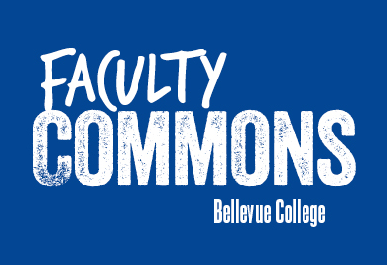**Have an idea for a pedagogical, curriculum or professional development opportunity for faculty and need funding and implementation support?** The Faculty Commons is always looking to fund programming that creates community, informs teaching practices and that can be disseminated across programs and divisions. Proposed programming can include workshops, speakers’ series, best practices sharing, book discussions and your best ideas. Ideas both big and small are welcome!

Faculty Commons will support proposals, particularly those that focus on fulfilling the [mission](http://www.bellevuecollege.edu/facultycommons/) of the Faculty Commons. To be considered for spring 2018, **please submit your proposal by Monday, November 6, 2017.**

[**Link to submit proposals**](http://bcfacultycommons.formstack.com/forms/2017_18_submission4fundedproposals)

For more information, please contact [Tonya Estes](mailto:tonya.estes@bellevuecollege.edu), Faculty Commons Chair.

**Participation in Faculty Commons Offerings Supports Promotions**

Whether you are tenured or part-time faculty, participation in most Faculty Commons activities fulfill the professional development requirements for promotions.  For each offering, please look at the Professional Development (PD) hours to determine if and how many hours you will earn for participation.

As a reminder, the Professional Development hours required for each promotion level is as follows.

**Tenured Faculty**

“The narrative application [for each promotion level] should detail demonstrated willingness to take on new responsibilities associated with the new rank [and] **reflective professional development related to content or pedagogy since last promotion.”** (Page 89, Appendix B, in the Faculty Contract 2014-2017 agreement)

Additional requirements for tenured faculty supported by the Faculty Commons include: professional development: The instructor…

A. Participates and reflects on professional development activities designed to stay current in their discipline and pedagogy of instruction.

B. Shows willingness to share knowledge with colleagues.

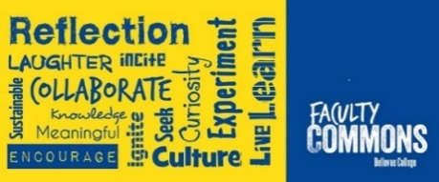C. Collaborates/makes connections with campus resources to improve instruction and benefit students.

**Adjunct Faculty**

To reach Lecturer 1 status, Adjunct Faculty must complete at least 30 professional Development hours.

To reach Lecturer 2 status, Adjunct Faculty must complete and additional 45 professional development hours.

For additional information, please visit our [Faculty Resources](http://www.bellevuecollege.edu/facultycommons/faculty-resources/) page.

## Meet our team!

|  |  |
| --- | --- |
| Picture of Tonya Estes, Faculty Commons Chair | **Tonya Estes, Faculty Commons Chair**  [**tonya.estes@bellevuecollege.edu**](mailto:tonya.estes@bellevuecollege.edu)  **Office Hours**: By appointment |
| Picture of Archana Alwar, Adjunct Faculty Mentor | **Archana Alwar, Adjunct Mentoring Lead**  [**aalwar@bellevuecollege.edu**](mailto:aalwar@bellevuecollege.edu)  **Office Hours**: Tue. and Thurs. 9:00 – 11:20 a.m. |
| Tim Jones, Faculty Commons Tenure Track Mentoring Lead | **Tim Jones, Tenure Track Mentoring Lead**  [**tim.jones@bellevuecollege.edu**](mailto:tim.jones@bellevuecollege.edu)  **Office Hours**: Tue. And Thurs. 12:30 – 1:20 p.m.  Wed. 12:30 – 3:20 p.m. |
| Picture of Carol Leffall, Chair - Faculty Assessment Coordinating Team | **Carol Leffall, Chair - Faculty Assessment Coordinating Team**  [**caroline.leffall@bellevuecollege.edu**](mailto:caroline.leffall@bellevuecollege.edu)  **Office Hours**: By appointment |
| Picture of Ann Minks, Online Teaching Best Practives Lead | **Ann Minks, Online Teaching Best Practices Lead**  [**aminks@bellevuecollege.edu**](mailto:aminks@bellevuecollege.edu)  **Office Hours**: Tuesdays 2:00-3:30pm. and by appointment. |
| Picture of Aris M. Andrade, Faculty Commons Program Manager | **Aris M. Andrade, Faculty Commons Program Manager**  [**aris.andrade@bellevuecollege.edu**](mailto:aris.andrade@bellevuecollege.edu)  **Direct:** 425-564-3344 |
| Picture of Sanaz Rohani, Faculty Commons Student Assistant | **Sanaz Rohani, Faculty Commons Student Assistant**  [**sanaz.rohani@bellevuecollege.edu**](mailto:sanaz.rohani@bellevuecollege.edu)  **Faculty Commons**: 425-564-3347 |

## Table of Contents

Assessment, Teaching & Learning …...5

Autism Cultural Responsiveness …….15

BCAHE …………………………….16

BC Foundation – Mini Grants ……..16

Call for Proposals! …………………....2

Contact Us …………………………..3

Faculty Commons Council ………...19

Fall Schedule Contributors …………18

Faculty Lunch Group ………………17

Instructional Tech & Learning ………8

Library and eLearning ………………12

RISE Learning Institute ……………...9

Teaching Squares …………………….7

Wellness & Community Building ….17



## President and Vice Presidents Office Hours

|  |  |  |
| --- | --- | --- |
| Dr. Jerry Weber, BC President | Thurs. Oct. 12 | 2:00 – 3:00 p.m. |
|  | **Thurs. Nov. 2** | **1:30 – 2:30 p.m.** |
| Dr. Gita Bangera, Interim VP of Instruction | **Tue. Oct. 24** | **2:30 – 3:30 p.m.** |
|  | **Tue. Nov. 14** | **1:00 – 2:00 p.m.** |
| Russ Beard, VP of Information Tech Services | **TBD** |  |
| Aaron Hilliard, VP of Human Resources | **TBD** |  |
| Dr. Sayumi Irey, Interim VP of Equity & Pluralism | **Wed. Oct. 25** | **1:30 – 2:30 p.m.** |
| Dr. Ata Karim, VP of Student Affairs | **Thurs. Oct. 5** | **11:30 - 12:30** |
| Ray White, VP of Admin. Services | **TBD** |  |

# ASSESSMENT, TEACHING AND LEARNING

## Preparing for the first day of class

**Fully Online: Oct. 2 to Nov. 6**

Preparing for the First Day of class is a workshop meant for new faculty and seasoned faculty. **Would you like for students to pick up your enthusiasm, be more likely to commit to your class, and be** **engaged in your class?** In this workshop, we will discuss strategies for both new and experienced faculty. This Workshop meets fully online and is designed to work with the face to face, hybrid and online classroom.

Upon completion of all modules, you will earn a certificate of completion validating **fifteen hours** of professional development and a **$100 stipend**.

[Register](https://bcfacultycommons.formstack.com/forms/fall_2017_preparing4thefirstdayofclass)by Friday, Sept. 22nd! Don’t miss out, we only have space for **10 faculty.**

Facilitator: [Archana Alwar](mailto:aalwar@bellevuecollege.edu), A&H faculty and Faculty Commons Adjunct Mentoring Lead.

**All deliverables identified by the facilitator must be completed to earn the indicated professional development hours and/or stipend.**

## Managing Online Discussions

**Fully Online: October 17 to November 14**

*Managing Online Discussions* is a workshop meant to teach best practices in engaged and dynamic discussions with students in an online environment.  The workshop is organized in a seminar style, meant to also engage students (you, the educator) in what has become a necessary part of teaching online and hybrid courses: The Discussion Board. During the four-week session, modules focus on a particular topic making use of Discussion Boards where you are expected to submit Initial *Posts* and Response *Posts* each week. This workshop meets fully online and is designed to work with the fully online classroom (though you should find relevancy here for Hybrid courses as well).

Upon completion of this workshop, you will earn a certificate of completion validating **fifteen hours** of professional development. This workshop fills up quickly. Don’t miss out, [**register**](https://bcfacultycommons.formstack.com/forms/fall_2017_managing_online_discussions)early!

For more information, please contact [Sara Sutler-Cohen](mailto:sara.sutlercohen@bellevuecollege.edu), Ph.D. Dept. of Sociology.

**All deliverables identified by the facilitator must be completed to earn fifteen professional development hours.**

## Adult Learning in the Online Environment

**Fully online: September 25 – October 9**

****This workshop engages you in some of the rich challenges and diversity that adult students bring to the online classroom. We will explore contemporary issues in teaching Adults, particularly in a mixed classroom made up of younger and older adults. For this course, we are discussing non-traditionally aged college students. Who they are, why they come (or come back) to college, and how best to reach and teach them. This workshop meets fully online and is designed to work with the fully online classroom though you should find relevancy for the Hybrid classroom as well.  If you want course materials prior to the start of the program, please email the facilitator at [sara.sutlercohen@bellevuecollege.edu](mailto:sara.sutlercohen@bellevuecollege.edu)

***Don’t miss out,*** [**register**](https://bcfacultycommons.formstack.com/forms/fall_2017_adult_learning_in_online_env) ***today!***

**All deliverables as identified by the facilitator must be completed to earn fifteen professional development hours.**

## Encouraging Critical Thinking with Study Circles

**Thursdays, Oct. 5, 12 and 19, 11:00 – 1:00 in D104E**

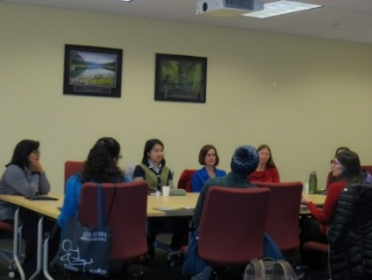Are you looking for a fun and innovative way of getting your students to look at your text more deeply? Do you want an activity that is flexible for you and your students? Study Circles is a teaching and learning strategy that can be used in all disciplines to help students analyze and think critically. Participants of this workshop will leave with a working knowledge of study circles and the tools to implement them in their classes. Participants will be required to attend all 6 hours of the workshop time and should plan for an additional 2 hours of homework. Upon completion of this workshop, participants will earn eight hours of professional development.

Don’t miss out…[register](https://bcfacultycommons.formstack.com/forms/fall_2017encouraging_critical_thinking) soon!

Facilitator: [Katie Austin-Miranda](mailto:kaustin@bellevuecollege.edu), A&H faculty.

# TEACHING SQUARES

## Online Teaching Squares

**Fully Online – Sept. 26 – Nov. 19**

Positive! Supportive! Online! Guided! Non-evaluative!

Review basic online teaching best practices, and then find positive attributes in a colleague’s hybrid or online course that you can apply to your own course.

Online Teaching Squares allows adjunct or full-time faculty to gain new perspectives and insights into their teaching through a supportive and completely non-evaluative process. It works through a process of reciprocal online class observation and self-reflection on one’s own online teaching.

Each Online Teaching Square consists of three to four faculty members, preferably from different disciplines, who observe each other's online course for a quarter and then discuss, through a guided process, what they’ve learned from the observations.

Upon completion of all deliverables, participants will receive sixteen **professional development hours** and a **$300 stipend**, funded by the Faculty Commons. There are only 12 spots available, so please [register](https://bcfacultycommons.formstack.com/forms/fall_2017_online_teaching_squares) soon! For additional information, please contact [Ann Minks](mailto:aminks@bellevuecollege.edu), Online Pedagogy Lead.

## Facilitated Teaching Square: Universal Design for Learning (UDL)

**First Meeting: Thursday, Sept. 28 1:30 – 2:30 p.m. (D104E)**

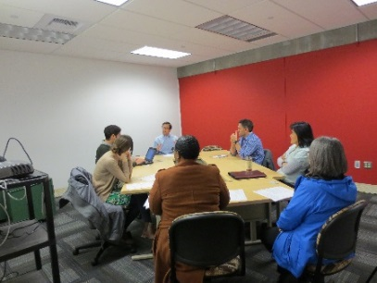In fall quarter, you can join fellow faculty members to observe and learn from one another through a non-evaluative process of reciprocal classroom observation and self-reflection. Faculty’s comments about this activity are “I have known that there isn’t a ‘one right way’ to teach, but by truly being in the mindset of observing the learning process across the spectrum, I was able to actually see that truth. It was humbling to see such diversity in teaching and learning.” Topics will be identified by the participants. Upon completion as defined by the facilitator, you will receive a certificate validating ten professional development hours and a stipend of $150.

All deliverables identified by the facilitator must be completed to earn the indicated professional development hours and/or stipend.

There are only **three** spots available so please [register](https://bcfacultycommons.formstack.com/forms/fall_2017_facilitated_teaching_square_udl) soon!

Facilitator: [Archana Alwar](mailto:aalwar@bellevuecollege.edu), A&H faculty and Faculty Commons Adjunct Mentoring Lead.

## Facilitated Teaching Square: Diversity.

**First Meeting: Tuesday, Sept. 26 1:30 – 3:20 p.m. (D104E)**

How do I adjust to differences among my students? How do I ensure that my curriculum addresses diversity? How inclusive is my teaching practice? Do I treat different demographic groups of students differently? During this teaching square, you will implement principles of education equity and social justice in the classroom. This teaching square will introduce ways to support all of your students by creating an inclusive course climate. Through these non-evaluative opportunities, you will learn theory and activities from a Faculty Commons facilitator and have the opportunity to apply what you learn by observing others and having others provide you with feedback.

Upon completion of all deliverables, participants will receive ten professional development hours and a $150 stipend, funded by Faculty Commons.

All deliverables identified by the facilitator must be completed to earn the indicated professional development hours and/or stipend.

There are only three spots available so please [register soon!](https://bcfacultycommons.formstack.com/forms/fall_2017_facilitated_teaching_square_diversity) Facilitator: Archana Alwar, A&H faculty and Faculty Commons Adjunct Mentoring Lead.

# INSTRUCTIONAL TECHNOLOGY AND LEARNING

## Gamification

**Fully Online: October 9 – November 17**

Have you wondered why game designers can get players to play their games for hours, learn non-transferable skills, and be excited about getting points or levels that have no meaning in real life?

Can we some of their ideas to make classes more engaging? In this fully online course we'll go through some of the concepts used in game design and how they can be used when designing courses. For example, we will design three activities that you can use immediately after the workshop. We will work asynchronously for 6 weeks, at a rate of about 2-3 hours a week.

All deliverables must be completed as defined by the facilitator to receive **$150 stipend and fifteen professional development hours.** [*Register soon*](https://bcfacultycommons.formstack.com/forms/fall_2017_gamification)for this interactive and fun workshop!

For additional information, please contact the facilitator, [Marcelo Guerra-Hahn](mailto:marcelo.guerrahahn@bellevuecollege.edu), IBIT faculty.

# COLLABORATIONS WITH FACULTY COMMONS



# Research ♦ Innovation ♦ Service ♦ Experiential

## Faculty Learning Community – Building Service into Your Classroom

**Date: Starting Winter 2018**

The RISE Learning Institute and the Faculty Commons are planning on launching a new Faculty Learning Community (FLC) for Project-Based Learning.  This community of practice will be open to faculty who want to add more projects to their courses, as well as to faculty who wish to make the projects that they are already doing even more impactful.  The FLC will discuss topics ranging from adding project-based work to a content-heavy course, assessing student project-based work in teams, working with community partners to design authentic projects, and so forth. If you are interested in learning more about this new Faculty Learning Community, please contact [Michael Reese](mailto:michael.reese@bellevuecollege.edu).

“Service-learning has been shown to have a positive influence on retention of students during their first year and beyond, with marked impact on some students in particular, including women and first-generation students” (Yob, 2014).

Service-learning, a “pedagogy of reflective inquiry linking students’ involvement in community service with their intellectual . . . development” (Saltmarsh, 1996), is a proven technique for:

· Building student engagement with course material,

· Helping students apply what they are learning to real-world situations,

· Creating a stronger bond with faculty and other students,

· Making social justice and other issues salient for students, and

· Increasing overall satisfaction with the class being taken.

With support from the [RISE Learning Institute](http://www.bellevuecollege.edu/rise/) and a group of fellow faculty from across campus, effective service-learning is both manageable and doable, and can have a positive impact on all involved. This Faculty Learning Community will have three 110-minute meetings per quarter, and will run winter, spring and fall 2018. In order to complete this program, participants are asked to commit to all three quarters and implement a service-learning course in the 2017-18 academic year.

Stipend: $1000 total ($250 each for winter and spring 2018, and $500 for fall 2018) for participants attending all sessions and upon completion of and participation in all portions of the FLC. Stipends are funded by the RISE Learning Institute. Enrollment is limited to 12 faculty members. Full-time and part-time instructors from all divisions are encouraged to apply. After completion of this entire program and participating in a final evaluation of it, you will earn a certificate of completion validating **75 professional development hours**. Faculty is encouraged to apply by **December 1, 2017.** Application link will be available on **October 6, 2017**. Meeting dates will be determined after finalization of the learning community. Applicants will be notified about acceptance by December 7th.

Submit your application at: <https://bcfacultycommons.formstack.com/forms/facultylearningcommunity2018>

*Saltmarsh, John (1996).  Education for critical citizenship: John Dewey’s contribution to the pedagogy of community service learning.*  Michigan Journal of Community Service Learning, *Fall, 13-21.*

*Yob, I.M. (2014).  Keeping students in by sending them out: Retention and service-learning.* Higher Learning Research Communications, *4(2), 35-57.*

## Electron Microscopy at Fred Hutch

**Workshop One:** Wednesday, Oct. 4, 2:30 – 4:00 p.m. or Thursday, Oct. 5, 2:30 – 4:00 p.m. at [**Fred Hutch**](https://www.fredhutch.org/en.html) – 1100 Fairview Ave. N, Seattle, WA 98109

**Workshop Two:** Wednesday, Oct. 11, 2:30 – 4:00 p.m. or Thursday, Oct. 12, 2:30 -4:00 p.m. at Bellevue College **S222**

**Would you like to learn how to use Bellevue College’s Scanning Electron Microscope (SEM)?**

Bobbie Schneider, Director of Electron Microscopy at the Fred Hutchinson Cancer Research Center, and Jason Fuller, Associate Professor of Biology at BC, will collaborate on a two-part workshop.

Participants will travel to [Fred Hutch](https://www.fredhutch.org/en.html) to learn about preparing biological samples for imaging.  Each participant will prepare his or her own sample—and, yes, you can choose what type of sample you would like to make.  The following week, each participant will examine that sample with the college’s scanning electron microscope on the second floor of the S Building.

Space in these workshops is limited to 15 participants, so please [register early](https://bcfacultycommons.formstack.com/forms/fall_2017_learn_about_electron_microscopy_fredhutch)! Priority will be given to those who intend to use the SEM with BC students. Participants will receive credit for five hours of professional development.

For additional information, please contact [Michael Reese](mailto:michael.reese@bellevuecollege.edu), Director of Program Development, RISE Learning Institute.

## Service Learning 101

**Friday, Oct. 6, 12:30 – 1:20 p.m. in D104H**

**Do you want your students to apply what they’re learning in class to a real-life situation?** **Do you want to engage your students with the community in a meaningful way? Do you want to build teamwork in the classroom and form a stronger connection with your students? Do you want to foster a greater sense of citizenship and service without losing out on your curricula?**

Come by the Faculty Commons and join the discussion about how service-learning works, and whether it makes sense for you to bring it into your classrooms. Learn about the resources that Bellevue College has to help you incorporate service and other experiential methods into your courses without spending too much time or exhausting yourself in the process. Join us in contributing to a campus community interested in and dedicated to building a greater sense of social and environmental justice, all while enhancing the student educational, civil, and professional experience.

**Join us, you’ll be glad you did! Please RSVP to** [**Sapan Parekh**](mailto:sapan.parekh@bellevuecollege.edu) **by October 5th.**

For additional information, please contact [Sapan Parekh](mailto:sapan.parekh@bellevuecollege.edu), Associate Director RISE Institute

## Community in the Classroom, Classroom in the Community

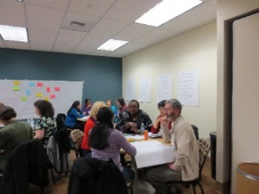**Wednesday, Nov. 8, 2:30 – 3:50 p.m. in D104H**

Mentorships. Service-Learning. External Interviews. Community-Based Research. Internships. Fieldwork. Citizen Science. Project-Based Learning. Consulting.

**What do these all have in common?** They are all considered High Impact Practices (HIPs) that enhance student learning through application of skills and knowledge to real-world situations. Four-year transfer institutions and potential employers alike embrace the demonstration of growth and learning that come from HIPs, particularly those that engage the community, as these all can. The challenge of High Impact Community Engaged Practices is often less in the implementation in class, and more in the "How do I create partnerships that are useful?" Perhaps the best source of ideas come from the community itself.

RISE and the Faculty Commons are bringing together a panel of community partners from local businesses, government, and non-profits to talk about what has, and has not, worked when creating and implementing curricular-community partnerships. They will talk about what you, as an instructor, should consider when seeking to build the community into your classroom, and take your classroom into the community.

**Please RSVP for the 80-minute program here** [Sapan Parekh](mailto:sapan.parekh@bellevuecollege.edu)**.**

## Panel Discussion on Undergraduate Research at BC

**Wednesday, Oct. 18, 1:30 – 3:00 p.m. in D104H**

Undergraduate research can enhance your course content while improving student learning outcomes. Research gives students the opportunity to be more inquisitive and motivated to explore, critically examine, and draw evidence-based solutions. Some BC faculty have been implementing undergraduate research experiences into their courses or in extracurricular contexts.

Come hear what they have learned, why they do it, and what challenges and benefits they see in using this teaching tool at this institution.

This is an interdisciplinary panel discussion including faculty from biology, psychology, chemistry and health sciences.

**Join us for this informative discussion! Please RSVP** to [Irene Shaver](mailto:irene.shaver@bellevuecollege.edu), Program Manager, RISE Institute.

## Library & eLearning

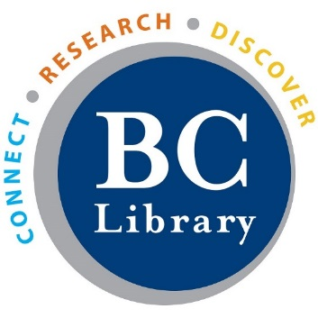

**Library Fall Quarter Hours**

**Monday – Thursday: 7:00 a.m. – 8:00 p.m.**

**Friday: – 7:00 a.m. – 5:00 p.m.**

**Saturday: Closed**

**Sunday: 1:00 – 5:00 p.m.**

The LMC has many resources available to assist faculty with their courses, including information on copyright and OER (Open educational resources).  We offer traditional face-to-face instruction for students in core subject areas, as well as virtual alternatives to educate students on information literacy. For more information about our library instruction program, please check out the **Faculty/Staff Resources** area of the LMC website or directly:

<https://www.bellevuecollege.edu/lmc/faculty-resources/>

In addition to these services, every division has a designated **liaison librarian** who is available to assist you with identifying resources for your courses or answering questions about how the library can partner with you.

**Arts & Humanities: David Oar Science: Elena Maans**

[david.oar@bellevuecollege.edu](mailto:david.oar@bellevuecollege.edu) [e.maans@bellevuecollege.edu](mailto:e.maans@bellevuecollege.edu)

**Health Sciences: Lisa Lapointe Social Science: Heath Hayden**

[lisa.lapointe@bellevuecollege.edu](mailto:lisa.lapointe@bellevuecollege.edu)[heath.hayden@bellevuecollege.edu](mailto:heath.hayden@bellevuecollege.edu)

**IBIT: Nicole Longpré**

[nlongpre@bellevuecollege.edu](mailto:nlongpre@bellevuecollege.edu)

**Collaboratory in the LMC**

The Collaboratory, located on the first floor of the library, is a joint project between the [Library Media Center](http://www.bellevuecollege.edu/lmc/) and the [RISE Learning Institute](http://www.bellevuecollege.edu/rise/). It is a public use space designed for flexible student collaboration and teamwork. The Collaboratory is primarily a student space, but may be occasionally reserved by faculty for designated activities.

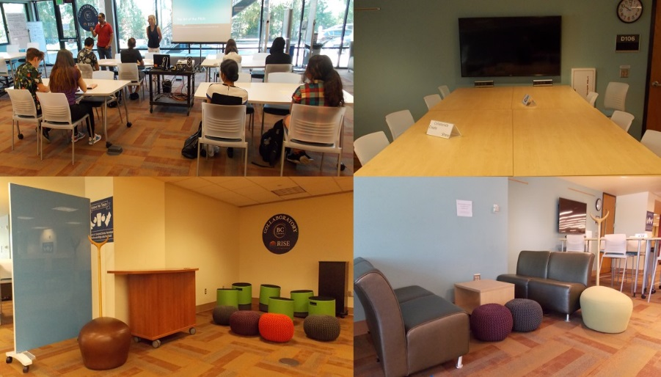The goal of the Collaboratory is two-fold: to provide a space for creativity and collaboration AND to make that process more visible.

[Collaboratory Use Procedure](http://www.bellevuecollege.edu/lmc/using-the-lmc/collaboratory/)

[Online form to reserve the Collaboratory Space.](http://www.bellevuecollege.edu/lmc/using-the-lmc/collaboratory/)

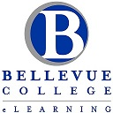eLearning Department is now located in the Library (D140). Instructional Designers will be available for walk-in help to assist instructors design their Canvas sites based on the most effective instructional design and Universal Design for Learning (UDL) principles. Both new to online/hybrid teaching and experienced instructors are welcome!

**eLearning interactive spaces include:**

* Collaboration space organized with a TV monitor equipped with AppleTV and Miracast for wireless connectivity.
* 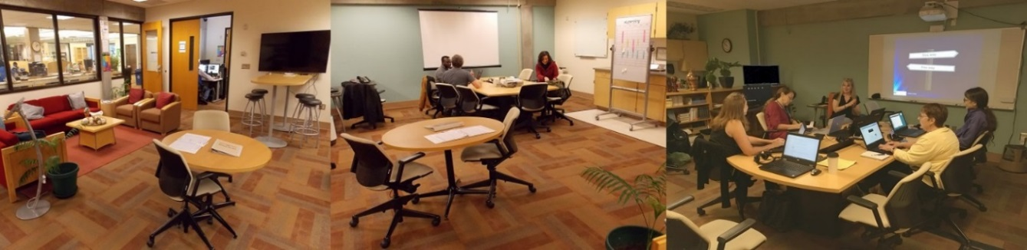Conference table with a short throw projector and a white board for group meetings.

Our Instructional Designers have been posting on our [eLearning Blog](https://www.bellevuecollege.edu/bcconnect/). Look for teaching tips, review new instructional tools, read about new apps and be knowledgeable about the journals and periodicals offered in our online database offerings in the Library.

Our goal for each workshop is for faculty to walk away with new skills and knowledge about practical tools that they can begin to use right away in their own courses.

[Sukirti Ranade](mailto:sukirti.ranade@bellevuecollege.edu) – eLearning Director can provide you with resources to build you Canvas classroom. She is located in the new eLearning & Media Center in D140

Contact: 425-564-4210

[Upcoming workshops](https://www.bellevuecollege.edu/bcconnect/workshops/):

• Canvas 101 • Accessibility 101 • Accessibility Basics for Microsoft Word and PowerPoint • Your Syllabus in Canvas • Canvas Gradebook • Copyright Workshop for Online Course Design • Providing Captions or Transcripts: A Universal Design Approach • Creating YouTube videos with Captions • Engaging Students through the Use of Canvas Groups and Canvas Peer Reviews

Workshop information will be available on [the eLearning website](https://www.bellevuecollege.edu/bcconnect/workshops/).

## Canvas 101

**This workshop is now offered through eLearning. Ongoing facilitated online instruction.**

**Starts on Monday, September 25th to Thursday, December 1st.**

**Think about it:**

* **How many times do we spend countless hours trying to figure out how to do something on Canvas?**
* **Invest some time and have your questions answered in this workshop!**

Canvas 101 is an excellent choice for new as well as more experienced instructors. This online based workshop is divided into 6 self-contained modules that acquaint you with primary features of the Canvas Learning Management System. It is self-paced, project-based, and guided-- a facilitator will be available to answer questions and to evaluate participant projects.  The work is designed to be completed within one academic term or less, and should require approximately 22 total hours to complete.  This course assumes that you possess basic computing skills: that you can input text into a computer, that you are familiar with basic computer file and folder organization, that you can operate a web browser, and that you can save, upload and download files. If you do not have these skills, you will need to acquire them before you register.

**PLEASE NOTE**: All faculty signing up for the Canvas 101 course are required to complete the   
[Faculty Canvas Orientation Quiz](http://www.bellevuecollege.edu/bcconnect/start-teaching-with-canvas/) before starting the class. Once you complete the quiz, you will get a **Sandbox** for testing Canvas content. You will need the **Sandbox** to submit this workshop’s assignments. **Don’t delay! Register today!** [Registration Link](https://bcfacultycommons.formstack.com/forms/fall2017canvas101)

Questions? Please connect with [Bruce Wolcott](mailto:bwolcott@bellevuecollege.edu), Instructional Designer & Communication Studies Faculty

**Accessibility 101: Principles of Inclusive Design**

Learn how you can make easy changes and additions to your Canvas courses in order to create an inclusive course environment for all students. The **Accessibility 101: Principles of Inclusive Design (ONLINE)** workshop is being offered with flexibility to complete assignments in six weeks.

The [Course Syllabus](https://bc.instructure.com/courses/1513059/assignments/syllabus) is public, so feel free to preview it before joining the course.

Participants will learn:

* The language of accessibility and the laws that most impact higher-ed.
* How to create accessible content based on the principles of Universal Design for Learning.
* To differentiate between access and accommodation.
* To create simple accessible documents, Canvas pages, PDFs, and/or PowerPoint presentations.
* How to identify and use the various approaches to caption a video.
* To take steps to ensure online technology is accessible to students, faculty, and staff on your campus.

**Start Date: October 2nd** [Registration Link](https://bcfacultycommons.formstack.com/forms/accessibility_101_the_basics_of_inclusive_design_fall2017)

The workshop is a facilitated six-week online course, designed to be completed in 20 hours. All faculty will be paid a $500 stipend upon successful completion of the workshop. Upon completion, you will achieve a Canvas badge, which will be displayed in your Canvas profile.

**Facilitators:**

[Debi Griggs](mailto:debi.griggs@bellevuecollege.edu), Instructional Designer & [Elizabeth Zahrt Geib](mailto:elizabeth.zahrtgeib@bellevuecollege.edu), Instructional Designer

**Disability Resource Center**

## Autism Cultural Responsiveness

**Wednesday, September 27, 12:30 – 1:15 p.m. (D104E)**

Cultural and communication expectations can set the stage for misunderstandings between students, classmates, and faculty. To complicate matters, faculty often don't know whether or not a student has an autism diagnosis, and the Disability Resource Center can't tell them! During this workshop, you will learn best practices to proactively provide for autistic students and others, as well as to respond to expected and unexpected situations. Be sure to bring your questions!

This presentation will be led by [Sara Gardner](mailto:sara.gardner@bellevuecollege.edu), Program Director/Instructor – Autism Spectrum Navigators.

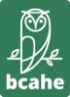**Bellevue College Association of Higher Education (BCAHE)**

## Adjunct Contract - Rights and Responsibilities

**Date: TBD**

Learn about your rights and your responsibilities as an adjunct instructor at Bellevue College. We will cover course assignment, office hours, promotion, annual/multi-annual contracts, class caps, course evaluations, performance reviews, and participation in college governance, professional development, leave, unemployment insurance, child care benefits, and more. **Lunch will be provided courtesy of Faculty Commons.**

Facilitator: Tobi Rosenberg, English Faculty

RSVP to [Aris M. Andrade](mailto:aris.andrade@bellevuecollege.edu) three days prior the lunch date - let us know of any dietary restrictions.

## BC Foundation- Mini Grants 101

**Wednesdays, Oct. 4 10:30-11:30 a.m., Oct. 25, 12:30-1:30 p.m. and Nov. 8, 2:30-3:30 p.m. in D104E.**

**Is there a special project, instructional enhancement, or professional development opportunity you have been wanting to do?** The BC Foundation has the Mini-Grant Program that can help support your ideas and goals. Mini-Grants are designed to support BC projects and programs that may not be eligible for support through other college funding sources. The Foundation awards grants each year ranging from $300 - $3,000. Preference is given to projects consistent with the college’s strategic plan as well as the President’s and Foundation’s priorities and goals. The Mini-Grant application is available from **September 25th to November 17th.**

More information and the application can be found on the Foundation website at [http://www.bellevuecollege.edu/foundation/what-we-do/mini-grants/.](http://www.bellevuecollege.edu/foundation/what-we-do/mini-grants/.%20%20)

# WELLNESS AND COMMUNITY

## Lunch is on us! - Faculty Lunch Group

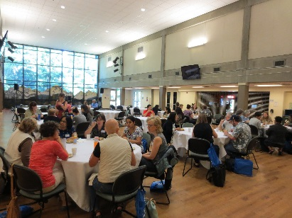

**All lunches will be in (D104H)**

These lunches are hosted by [**Faculty Commons**](http://www.bellevuecollege.edu/facultycommons/) and facilitated by [Archana Alwar](mailto:aalwar@bellevuecollege.edu), Adjunct Faculty Mentoring Lead. These are opportunities to meet other faculty and learn strategies to improve our students’ success. The schedule of topics is:

* **Tuesday, Sept. 26, 12:30pm – 1:20pm ♦ Theme: Creating a Conducive Classroom Environment**
* **Wednesday, Oct. 18, 12:30 – 1:20pm ♦ Theme: Using Reflection to Create Self-Regulated Learners**
* **Thursday, Nov. 16th 10:30 –11:20 a.m. ♦ Theme: End of Course Evaluations and Preparing Yourself**

Please RSVP to [Aris M. Andrade](mailto:aris.andrade@bellevuecollege.edu) three days prior the lunch date - let us know of any dietary restrictions.

## Meditation

**Mondays, Sept. 25 through Nov. 27, 12:30 to 1:00 in D104E**



In this session, we will use an ancient Chinese health care regimen that ties together posture, breathing, and focus. This practice can help maintain health, heal bodies, calm minds, and reconnect with our spirit. We will use WuQinXi as an exercise to lead the practice.

You’ll leave the room relaxed and re-energized!

Facilitator: Wei Geiger, A&H, World Languages.  **No registration needed.**

## My pets make me breakfast: How to get started with backyard chickens.

**Wednesdays, Oct. 4, 12:00-12:50 and Oct. 25, 12:30-1:20 p.m. (D104H)**

In this session you will learn the basics that you would need to know to get started with backyard chickens.  What are the regulations in your area? What sort of protection to chickens need? Should you start with eggs, chicks, hens? Do you need a rooster? How much work are they? Can you teach them tricks? Is raising chickens cruel? What do you do if they get sick?

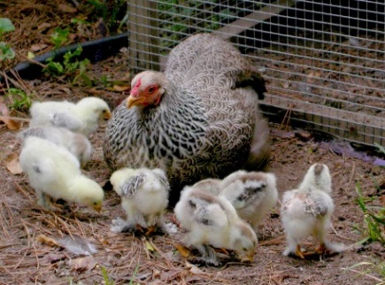This workshop, will combine silly chicken stories with helpful information about raising chickens. Participants will be able make an intelligent decision on their level of interest in having their own backyard flock.  **Assuming adequate production from the facilitator’s flock, a half dozen eggs will be given as a door prize to one participant.**

Join us for this fun and informative activity! Besides, you will get to network with other BC employees!

**Please RSVP to** [**Rebecca Cory**](mailto:rebecca.cory@bellevuecollege.edu)**, Associate Dean - Office of Instruction by Oct. 2nd.**

# FALL SCHEDULE CONTRIBUTORS

## Many Thanks to our contributors!

**Archana Alwar**

**Aris M. Andrade**

**Katie Austin-Miranda**

**Dr. Gita Bangera**

**Russ Beard**

**Dr. Rebecca Cory**

**Sara Gardner**

**Wei Geiger**

**Marcelo Guerra-Hahn**

**Lauren Hardin**

**Aaron Hilliard**

**Dr. Sayumi Irey**

**Dr. Tim Jones**

**Dr. Ata Karim**

**Ann Minks**

**Mandie M. Nash**

**Sue Nightingale**

**Sapan Parekh**

**Michael Reese**

**Tobi Rosenberg**

**Irene Shaver**

**Dr. Sara Sutler-Cohen**

**Dr. Jerry Weber**

**Ray White**

**Bruce Wolcott**

# FACULTY COMMONS COUNCIL

[Jennifer Anderson](mailto:jeanders@bellevuecollege.edu) – Council Member – Arts & Humanities

[Dr. Gita Bangera](mailto:gita.bangera@bellevuecollege.edu) - Interim Vice President of Instruction – *ex-officio*

[Virginia Bridwell](mailto:virginia.bridwell@bellevuecollege.edu) - Dean, Social Science – *ex-officio*

[Dr. Rebecca Cory](mailto:rebecca.cory@bellevuecollege.edu) – Assoc. Dean Office of Instruction - *ex-officio*

[Jean Irons-Dendy](mailto:jean.dendy@bellevuecollege.edu) – Council Member – Health Sciences, Education and Wellness Institute

[Lisa Harris](mailto:lisa.harris@bellevuecollege.edu) – Faculty Commons Chair, IBIT

[Dr. Katharine Hunt](mailto:katharine.hunt@bellevuecollege.edu) - Council Member – Social Science

[Seema Jejurikar](mailto:sjejurik@bellevuecollege.edu) – Council Member - Science

[Dr. Vivienne McClendon](mailto:vivienne.mcclendon@bellevuecollege.edu) – Dean, Library – *ex-officio*

[Sue Nightingale](mailto:sue.nightingale@bellevuecollege.edu) – BC Association of Higher Ed (BCAHE) President – *ex-officio*

**Faculty Commons Council Alternates**

[Dr. Stephanie Brommer](mailto:stephanie.brommer@bellevuecollege.edu) – Alternate Council Member – Social Science

[Carl Freeberg](mailto:carl.freeberg@bellevuecollege.edu) – Alternate Council Member - IBIT

[Jun Xu](mailto:jun.xu@bellevuecollege.edu) – Alternate Council Member – Arts & Humanities

Bellevue College does not discriminate on the basis of race or ethnicity; creed; color; national origin; sex; marital status; sexual orientation; age; religion; genetic information; the presence of any sensory, mental or physical disability; gender identity or veteran status in educational programs and activities which it operates… Please see policy 4150 at <http://www.bellevuecollege.edu/policies/>.