Requesting Accommodations
Requesting accommodations is a process that must be done every quarter. A request for accommodations lets us know that you are registered for classes for the quarter and we can then coordinate and plan your accommodations. By requesting accommodations as soon as possible after you’ve registered for classes you give the DRC as much lead time as possible to get your accommodations set up going into the next quarter.
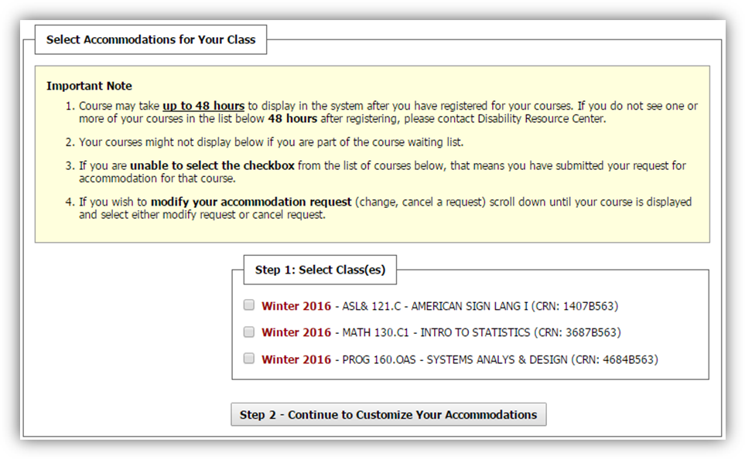
Once you’ve logged in to MyDRC, the beginning of the accommodations request process is located in the “Overview” section of your Dashboard – the default homepage when you log in. There might be some messages or notices listed first (they have a light yellow background), go ahead and scroll past those until you find the heading “Select Accommodations for Your Class.” There may be a light yellow box titled “Important Note”—what you’ll need are the Step 1 and Step 2 boxes underneath that:

Step One: Select Class(es)
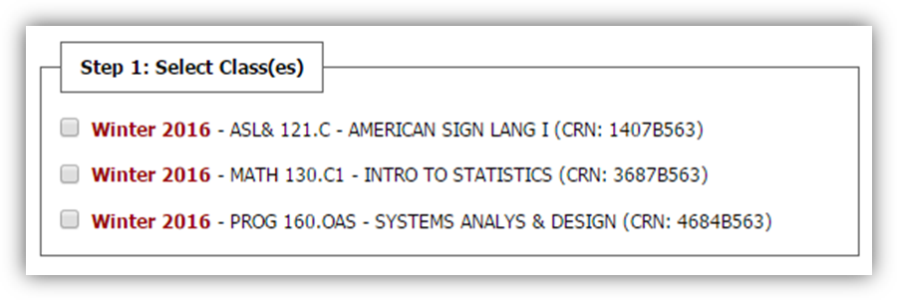
Find the box labeled “Step 1: Select Class(es).” (It should look similar to the one below except with the current quarter and your classes listed.) If you’ve finished registering for classes, but don’t see them listed here, contact the DRC about what steps to take next.

To select a class click the checkbox next to it. You can select as many of your classes as you like – after this step you will customize your approved accommodations individually for each class. So there’s only three reasons not to select all classes at this point. Either:
- You are unsure if you’re going to use ANY accommodations for the class. For some classes, like Art, you may not have any applicable accommodations. Or,
- You are unsure if you’re going to take the class and may end up dropping it. We still recommend to request accommodations, if you do not end up dropping the class may regret not have certain accommodations available to you for the first week or two). Or,
- It’s not actually a class and you don’t need to request accommodations, such as Payment Deferral or the Application Fee applied to certain programs, which are good to not select.
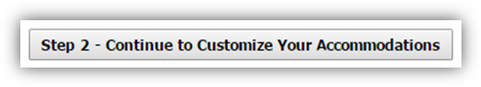
We do recommend requesting accommodations for all classes that you might end up using accommodations for. However, you do have the option of coming back and requesting accommodations later if you decide you want to use them. It is important to note that accommodations are not applied retroactively and will only be made available from the date you request them, moving forward. Once you’ve checked the classes you want, click the gray button labeled “Step 2 – Continue to Customize Your Accommodations”:

Navigating the Accommodation Request Page
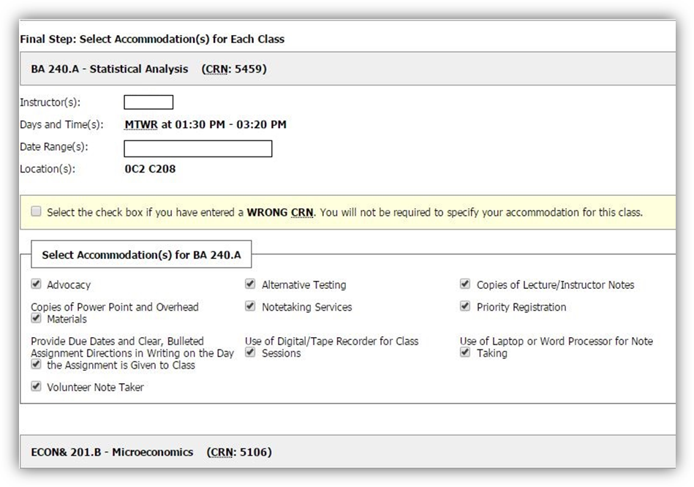
Once you click the Step 2 button, your browser will take you to a new page where you can select the accommodations you want for each of your classes. The page will be broken up into multiple sections for each of the classes you selected on the previous page and will look similar to the picture below.
NOTE: Picture is of different classes than selected in previous images.
Each of these sections can look a little complicated, since they’ve got a lot of information, so the next part of this tutorial will briefly outline the major features:
- Course Heading: The gray bar at the top lists the course ID, name, and CRN (course reference number).
- Course Information: Lists instructor’s name, and information about when and where the class meets.
- Wrong CRN box: If you have accidentally selected a class that you do NOT wish to select ANY accommodations for, selecting this box for that class will allow you to continue to select accommodations for your other classes while skipping that one class and accept your submission.
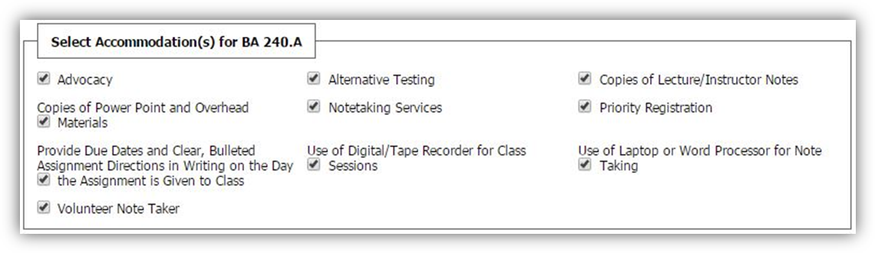
These first three parts can help verify which class you are selecting accommodations for. Once you know you’re looking at the right class, you can move on to the box that’s labeled “Select Accommodation(s) for…” followed by the course ID for your class. This is the important bit of the form:
Inside the box each of your accommodations will be listed with a checkbox next to each of them.
- By default, all accommodations are automatically selected.
- To de-select any accommodation (NOT request it) click the checked box to uncheck it.
- It is highly recommended you choose every accommodation you think you might use.
  - Failure to do so may lead to some accommodations not being made available, or their availability being delayed.
  - For example, if "Alternative Testing" were not selected the instructor would not receive the link to fill out the MyDRC Test Proctoring Form and you would not be able to schedule testing appointments with MyDRC or use your testing accommodations.
- Feel free to choose different accommodations for different classes
Additionally, most accommodations are listed individually but two are listed by groups:
- Alternative Testing – has too many individual accommodations to list each individually.
- Notetaking Services – are all very similarly titled.
- When either of these groups are selected your individual accommodations ARE listed in the letter sent to your instructor.
  - You are also CC’d a copy at your BC email address
  - To see your accommodations click the “My Eligibilities” link on the left-hand menu.
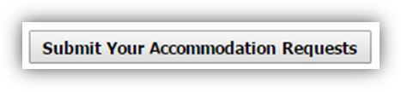
Once you’ve finished with one class, move to the next. Once you’ve finished with all the classes you want accommodations for click the button labeled “Submit Your Accommodation Requests” located near the bottom of the page:

Accommodations Request Submitted
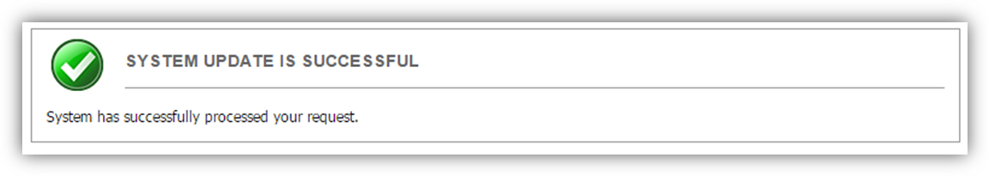
When you’ve submitted the request your browser will return you to your Dashboard. There should be a notification at the top of the Overview section:
This is confirmation that your accommodation requests have been submitted to the system and will be processed by the DRC before being sent to your instructors.
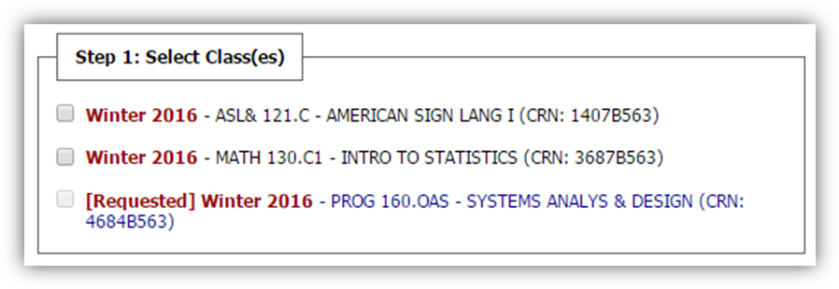
Then if you scroll down the page you’ll see that in the “Step 1: Select Class(es)” box any classes that you’ve requested accommodations for will be formatted differently:
There will be “[Requested]” written out in red before the quarter and year and the course information will be a blue-colored font instead of black.
In the above example accommodations have only been requested for the last class, PROG 160, in order to provide a visual contrast of what the format looks like before (ASL & MATH) and after (PROG 160) accommodations have been requested.
If you continue to scroll down the page you’ll find a record of your accommodation requests will appear in the “List Accommodations for (Quarter)” section toward the bottom of the Dashboard. If you need to make adjustments to your request – such as request an accommodation you initially did not, or request a recently approved accommodation – or cancel a request this is where you would do that. More information about these features in a future tutorial.
As a final confirmation, you will receive a modified copy of the letter in your BC email. You can also see all emails sent to you on behalf of MyDRC (just the system, not the DRC office) by clicking the “My Mailbox” link on the left-hand menu.

Questions?
Please feel free to contact the DRC with any questions, concerns, or issues you have with this process. We are her for you, let us know how we may be of benefit!

