Rescheduling Exam Request in MyDRC
  - A Tutorial for Bellevue College Students from the Disability Resource Center

Introduction
Occasionally it becomes necessary for DRC staff to make a request for students to adjust their testing appointment time, date, location, accommodations, or some combination thereof. Sometimes the request may be even more complicated than that! When this is necessary the DRC staff can submit a request through MyDRC which notifies students of the required change. There are two specific types of requests DRC staff can submit:
- Reschedule Exam Request
  - This proposes a new date and/or time for an already scheduled exam.
  - If accepted by the student the exam appointment is automatically updated in MyDRC.
- Request Student to Contact DRC
  - This sends an email to a student asking them to contact the DRC.
  - Included is a “Staff Rescheduling Note” which provides information about why the appointment needs to be rescheduled.
Both of these request types and how to respond to them will be thoroughly explored in the following sections of this tutorial. First we will look at what it looks like to receive a “Reschedule Exam Request” and how to respond to one; for information on the other request type skip ahead to “Request Student to Contact DRC” further along in the tutorial.

Reschedule Exam Request
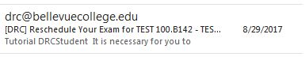
A student’s first indication that the DRC is attempting to reschedule an exam will be receiving an email from MyDRC with a subject including:
- DRC
- “Reschedule Your Exam”
- Class Name
IMPORTANT: Emails are sent to the email address used when registering with the DRC – most likely a Bellevue College email address. If Bellevue College is not the student’s primary email, please follow these directions Bellevue College’s ITS to set-up an account to forward all BC emails to the student’s primary email account. If an email was not supplied during application to the DRC or it was not a BC email, please contact the DRC as the BC email is also used to set up a student’s username - allowing them to login to MyDRC.
There are two parts to this email and there will be subsections of this tutorial to address each of them:
- Proposed Changes
- Original Request Details
Additionally, a third subsection has been added to cover accepting a reschedule request or what to do if the reschedule option provided is unacceptable.

Proposed Changes
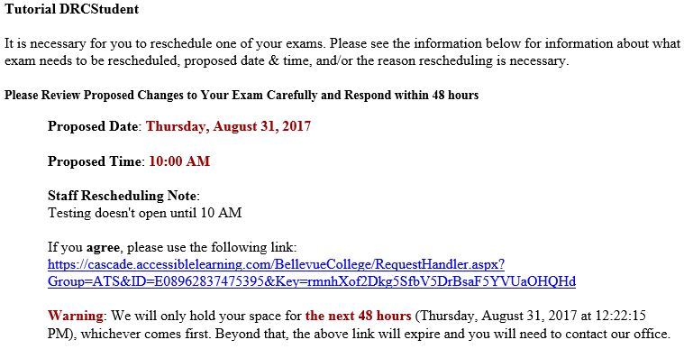
The body of the email is broken down into two sections. The first section includes an introductory message, the proposed changes to the exam request, and a link to click if the student agrees with making the changes. It should look similar to the following:
As you can see, the email begins with a brief explanation that an exam needs to be rescheduled and goes on to list out the proposed changes. Elements included are:
- Reminder to respond within 48 hours:
- Proposed Date:
  - Required to be entered: May not differ from original date, but will always appear
- Proposed Time:
  - Required to be entered: Most likely to differ from original, but may not; will always appear.
- Staff Rescheduling Note:
  - Not Required: May be left blank, so may not appear at all
- Confirmation Link:
  - “If you agree, please use the following link:” clicking this link will confirm changing the exam to the proposed date and time.
- Warning:
  - “We will only hold your space for the next 48 hours…” Another reminder that the link is only good for 48 hours or until the proposed reschedule date & time, whichever is first.
There are many reasons why an exam request may be requested to be rescheduled, but one of the most common reasons is that the original date and/or time requested does not meet with the instructor’s scheduling requirements. If this is not the stated reason for requesting a reschedule, then please make sure the new requested date and/or time or any modified date and/or time also meets with the instructor’s scheduling requirements. These requirements can be found by viewing the agreement (MyDRC Test Proctoring Form) when making or modifying an exam request. (Access the Modifying an Exam Request Tutorial here.) Additionally, contacting your instructor to receive clarification or permission for a particular test date and/or time might also be a good idea. Ideally you should have the instructor CC their reply to the DRC so that we have the same information and can confirm your exam request that much sooner.

Current Exam Request
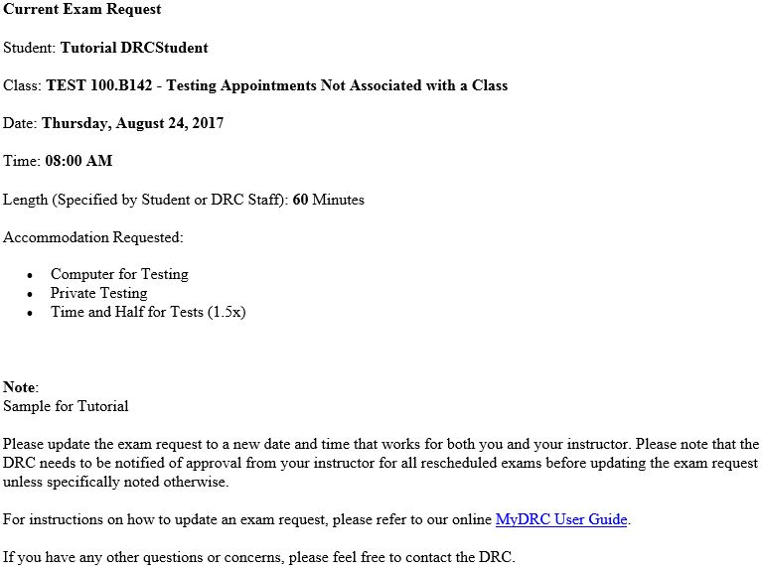
The second half of the email includes information on the original exam request details including requested accommodations (not included in the first half) and information on how the student can modify exam requests (if the suggested rescheduling is not acceptable, for example). It should look similar to the following:
The second half of the email is a pretty straight-forward display of the original exam request for comparison purposes to the reschedule request above it. Included are:
- Class name
- Originally requested exam date
- Originally requested exam time
- Test Length (if specified)
- Accommodations Requested
- Additional Note added to the request
Also included is a link to the MyDRC User Guide in case the proposed changes included in the reschedule request are unacceptable students will be able to make acceptable updates to the appointment themselves that may be acceptable. DRC Contact information (not shown) is also included in the event that students prefer to have DRC staff reschedule the appointment or they have other questions not addressed by the Reschedule Request Email.

Accepting a Reschedule Request
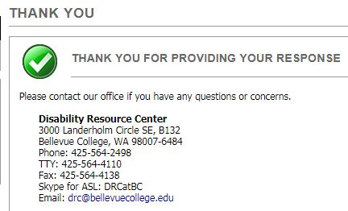
If a student agrees with the proposed reschedule date and/or time with no further changes necessary, they should click on the “Confirmation Link” included in the Reschedule Request Email following “If you agree, please use the following link:” Clicking on this link take them to the login page for MyDRC; once logged-in they’re automatically provided with a verification screen that thanks them for responding:
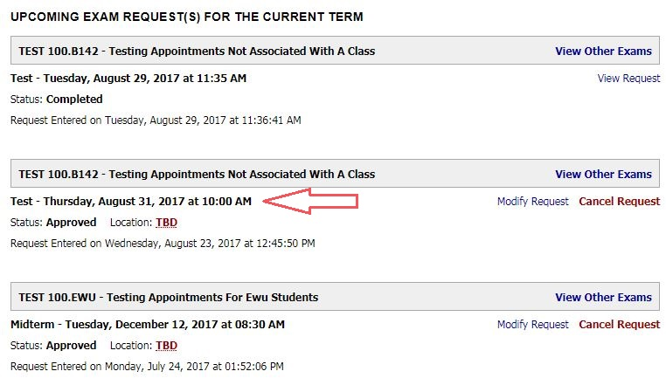
If the student then navigates to the Alternative Testing section of their Dashboard, they’ll be able to locate the updated appointment among their list of appointments:
If the proposed reschedule details are not acceptable or additional changes need to be made to the existing exam request the student can contact the DRC for other options (DRC contact information is at the bottom of the Reschedule Exam Request email, but not shown in the images) or login to their MyDRC account and modify the exam request themselves. (Access the Modifying an Exam Request Tutorial here.)

Request Student to Contact DRC
Occasionally the DRC staff will not know exactly how to proceed forward with rescheduling an exam request on a student’s behalf. This can be due to the accommodations involved, they type of testing appointment it is, when it is originally scheduled to take place, or any number of other variables. Instead they will request that the student contact the DRC to discuss different options and determine what works best for the student’s situation and the time involved. This process is extremely similar to the Reschedule Exam Request, except there’s no option to “agree” with the suggested reschedule details and the student will almost always end up contacting the DRC.
The first indication that a student needs to Contact the DRC about an exam request will be receiving an email from my DRC. Unfortunately this email looks nearly identical to the one described earlier in the “Reschedule Exam Request” section of this tutorial. It’s not until the email is opened that it will look any different. Like the “Reschedule Exam Request” email there are also two parts to this email:
- “Please Contact Our Office As Soon As Possible”
- Original Request Details

Please Contact Our Office As Soon As Possible
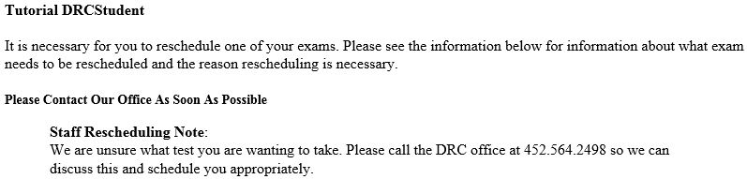
Once the email has been opened its difference from the Reschedule Exam Request email becomes immediately apparent. Instead of a breakdown of a new exam details, there’s a simple introductory phrase explaining why the email is being sent followed by the “Please Contact Our Office As Soon As Possible” header and then the “Staff Rescheduling Note” beneath that:
Unlike the “Reschedule Exam Request” email which has several pieces of information about a new testing appointment, the “Request Student to Contact DRC” only has one:
- Staff Rescheduling Note
  - This section will have any information the DRC Staff member felt was important for the student to know when suggesting they contact the DRC office to reschedule their testing appointment. In some cases it may have appointment options which would allow a student to login to their MyDRC account and modify the exam request themselves. (Access the Modifying an Exam Request Tutorial here.)
There’s no link to follow to complete the needed action – instead a student simply needs to contact the DRC Office in order to get their exam rescheduled to an appropriate time and/or date.
The bottom section of the email contains the “Current Exam Request” and is identical to the information covered above in the subsection of the same name for “Reschedule Exam Request”. This information will be useful to have when DRC staff try to locate the appointment that needs to be rescheduled.

Summation and Questions
In this tutorial we have covered how to reschedule an exam request when prompted to do so via an email from MyDRC as well as when and why contacting the DRC directly might be a better option. We also discussed that modifications to time and date on exam requests may require instructor approval in order for DRC Staff to approve them.
This system is how a DRC staff member will suggest changes to exam requests already submitted by a student, whereas the “Modify or Cancel an Exam Request” process would be the procedure for students to go about adjusting their own testing appointments.
If you have any questions about anything in this tutorial, MyDRC, or anything Disability related, feel free to connect with us:
Campus Office B-132
DRC Testing B-142
Phone: 425-564-2498
Fax: 425-564-4138
TTY: 425-564-4110
Skype for ASL: DRCatBC
Email: drc@bellevuecollege.edu
https://www.bellevuecollege.edu/drc

